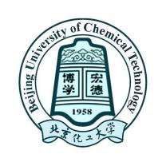

Dear student FULL NAME,

I am very pleased to provide this letter as an acceptance letter for you to come to Beijing University of Chemical Technology (BUCT) as a Master/PhD student for 3 /4 years, starting on September 1, 20XX and ending July 15, 20XX, in my research center in College of XXXXXXX. I believe that your Language (Chinese / English) has met the requirement to study in the Master or PhD program (major in XXX ).

After your registration, I would like to have you to conduct research in the area of XXXX. My research center is very well equipped. I hope that your background of student’s highest degree will be a significant contribution to my research team. I am sure that your study experiences and further research training to be gained at BUCT will be very helpful for your future career.

Please go to the website of International Office of BUCT to view the information of application and do make sure all your necessary materials are submitted before the deadline. Please apply for Chinese Government Scholarship, which is a prerequisite for admission.

Please feel free to contact me if you have any questions about my acceptance letter. I look forward to your joining my research group at BUCT.

Sincerely,

Prof’s NAME.
Professor
College of xxxxxxx
Email:
Phone:
Signature：

